# 

# ACADEMIC AND ADMINISTRATIVE SYSTEM

**Submitted By**

Abhishek Kumar

1. **Title of the project**

Academic and administrative system

1. **Abstract of the project**

The **Academic and Administrative System** is an ERP-based solution designed to manage the administrative and academic activities of a college or educational institution. The current systems often require manual processes that are time-consuming and prone to errors. Our proposed system automates and streamlines various college operations such as student information management, admission processing, attendance management, and event coordination. The system is built using a MongoDB database to store the college's data securely. Users such as admins, teachers, and students will need to register to access the system. This web-based system aims to increase operational efficiency, reduce manual work, and offer an organized platform for managing college affairs.

**Unique Features**

• **User-Friendly Interface**: The system features an intuitive and easy-to-navigate interface for all user roles (Admin, Faculty, Student).

• **Easy Registration**: Simplified registration for students and faculty.

•**Comprehensive Management**: Manages academic (attendance, exams, grades) and administrative (admissions, events, staff) functions.

•**Responsive Design**: Works seamlessly on all devices (desktops, tablets, and smartphones).

• **Real-Time Data Processing**: Real-time updates for student attendance, grades, and other academic data.

1. **Keywords**
   1. **Generic Technology keywords**
      * Operating System – Windows 10 or above
      * Databases – MongoDB
      * Programming – JavaScript, Node
      * Browser – Any Modern Browser
2. **Specific Technology keywords**

#### **Generic Technology Keywords**

* **Operating System**: Windows 10 or above
* **Databases**: MongoDB
* **Programming Languages**: JavaScript, Node.js
* **Browser**: Any modern browser (Google Chrome, Firefox, Edge, etc.)

#### **Specific Technology Keywords**

* **Frontend**: React.js
* **Backend**: Node.js, Express.js
* **Database**: MongoDB
* **Full Stack**: MERN Stack (MongoDB, Express, React, Node)

1. **Functional components or module of the project**

#### 

#### **Login Page (for Teacher, Admin, and Student)**

The login page will authenticate users based on their roles (Admin, Teacher, or Student) to provide appropriate access to the system. Secure login mechanisms (e.g., JWT tokens) will be implemented.

#### **Admin Dashboard**

The admin dashboard will allow the administrator to manage the entire system, including the ability to add, modify, or delete student and faculty records, track attendance, manage events, and more.

#### **Student Dashboard**

The student dashboard will allow students to view their academic progress, including attendance records, exam schedules, grades, and event notifications.

#### **Faculty Dashboard**

The faculty dashboard will provide teachers with tools to record attendance, grade assignments, view student details, and manage their teaching schedules.

1. **Flow Chart**

**Admin**

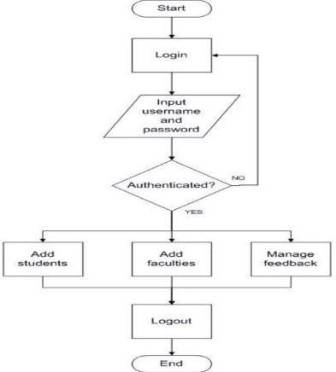

**Student**

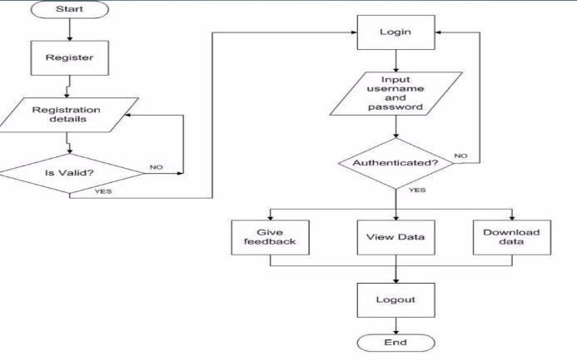

**Faculty**

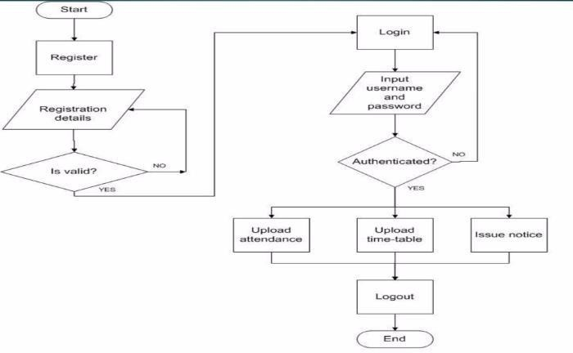

1. **Requirements**
   1. **Hardware requirements: -**

* RAM: Minimum 4 GB (further increase that as per requirement.)
* Storage: Minimum 256GB (further increase that as per requirement.)
  1. **Software requirements: -**
* Database: Mongo DB
* Runtime Environment: Node JS
* IDE: VS Code

1. **Guidelines and References**

[1]. https://www.slideshare.net/mohit0749/collegeerp-system-project-48367405

[2]. https://1000projects.org/college-erpsystem-cms.html

[3]. (PDF) A Research Paper on College ERP System | suraj kumar- Academia.edu https:/[/www.academia.edu/35401042/A_Resear](http://www.academia.edu/35401042/A_Resear) ch_Paper

[4]. MERN Stack https:/[/www.geeksforgeeks.org/mern-stack/](http://www.geeksforgeeks.org/mern-stack/)

[5]. https:/[/www.ijarcce.com/upload/2013/june/4-](http://www.ijarcce.com/upload/2013/june/4-) shobha%20bharamaoudar-

WEB%20BASED%20STUDENT%20INFORMA TION.pdf

[6]. https://en.wikipedia.org/wiki/HTML

[7]. https://en.wikipedia.org/wiki/JavaScript